Product Backlog Report
by
Kusal KC, Roman Solovev, Amadey Kuspakov, Zuhair Abbas

OVERVIEW
This report presents product backlog for the Cross Service project. In the following sections, you can find the complete product backlog, user stories, and analysis of a few selected stories with a defined INVEST criterion. The main user actors concerned with the user stories are the service providers and customers.

PRODUCT BACKLOG
EPICS | FEATURES | FUNCTIONALS
Implement User Profile Management | Allow user account creation. | - Webpage with registration form.  - Webpage with login form.  - Password recovery.
Implement User Profile Management | Allow users to login to the system.
Implement User Profile Management | Allow users to delete/update their account. | - Web page with options to edit/update account info or delete account entirely.
Implementing Service Management | Allow making a service/request post. | - Creating a service/request page with ability to change/delete it.
Implementing Service Management | Allow editing/deleting a service/request post.
Implementing Service Management | Allow searching for services using various criteria. | Searching for services by name, type, category, location, etc.
Developing Data Storage Mechanism | Develop simple APIs to fetch data as necessary. | Provide functions to fetch data as requested by different app parts or developers.
Supporting Notification Services | Notify users about account/post updates. | Implement direct notification in dashboard.
Supporting Notification Services | Implement fast notification. | Fast notification by email and/or services like Telegram.

USER STORIES
We have dissected user stories according to the epics and the user types involved.
Epic #1: Implementing User Profile Management
New User
- As a new user I want to be able to register to use the service.
Existing User
- As an existing user I want to login to see my current status.
- As an existing user I want to update my profile to keep account information up-to-date.
- As an existing user I want to delete my profile in case I do not want to use service any more.

Epic #2: Implementing Service Management
Service provider
- As a service provider I want to be able to post a service I want to provide to make profit.
- As a service provider I want to edit my posted service information to indicate any changes.
- As a service provider I want to remove an existing service in case I am not longer intend to provide it.
- As a service provider I want to search for similar services to compare my service with others.
Customer
- As a customer I want to search for a particular service by name or category to request it.
- As a customer I want to contact a service provider directly using contact information to order the service.
- As a customer I want to cancel my request because I no longer need it.
- As a customer I want to sort services by location, price, categories to see the services that are more relevant to me.

Epic #3: Developing Data Storage Mechanism
Developer
- As a developer I want to fetch data from database to generate a report.
- As a developer I want to save backup automatically to prevent data loss.

Epic #4: Supporting Notification Services
Service provider and customer
- As a user I want to be notified about any updates that happens to my post (comments, replies, etc) directly through notification bar.
- As a user I want to be able to subscribe or unsubscribe to email and telegram notifications to receive information faster.

INVEST
These are our INVEST criteria used to evaluate the five selected user stories:

Independent | Negotiable | Valuable | Estimatable | Size appropriate | Testable
1 - Fully independent | 1 - Written Contract | MH - Must Have | 1 - Hard to estimate | 1 - Large (need to split) | 1 – Clear & Testable by developer
2 - Dependent on <50% | 2 - Developer discretion | SH - Should Have | 2 - Need a prototype | 2 - Appropriate size | 2 - Testable only by end users
3 - Dependent of >50% | 3 - Negotiable | SU – Sufficient (not really required, but good to have) | 3 - Comparable | 3 - Relatively small
4 - Fully dependent |  |  | 4 - Easy to estimate

Independent - We decided to have 4 criteria to more precisely depict the dependence of different user stories on each other. (1) in our case is a user story that covers the basic functionality and the other stories will be based on this functionality. On other hand we have fully dependent stories (4) that cover multiple features and rely on other more atomic stories. 2-3 can be simply described as partially dependent and strongly dependent.

Negotiable - 3 criteria to the differ the functionality that is written in the contract, that was implemented by developer’s choice and negotiable things.

Valuable - Basically MH is main functionality from the service specification, SH is things that can be done to improve user experience and SU are good things to implement, but they can be easily discarded.

Estimatable - Again 4 criteria to precisely depict things from (4) - functionalities that can be easily estimated by developer (by his experience or inner view of the product), (3) - things that can be compared with other products and based on their experience brought to service, (2) - something that require prototype to work on to finally release and (1) - difficult functionality that will require much time to work on.

Size appropriate - (1) is for large functionalities that will work more accurate and be more user-friendly if they will be split to separate sprints, (2) is an appropriate size for one sprint to be implemented and (3) is relatively small to cover inside 1 sprint with other similar tasks.

Testable - (1) is something that is clear enough and can be fully covered by developer team to be sure that everything works fine and (2) is functionalities that can only be tested with the help of end users, e.g. user interface’s effectiveness.

USER STORIES with INVEST
Following is the screenshot of the user stories with INVEST evaluation. Below, you can find the reasoning for 5 user stories selected (highlighted in green):
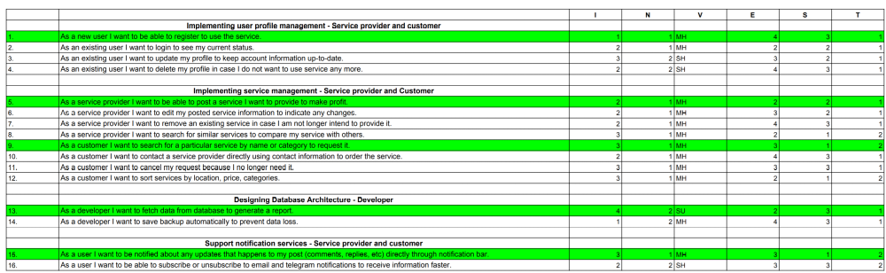

As a new user I want to be able to register to use the service.
Independent | Negotiable | Valuable | Estimatable | Size appropriate | Testable
1  Because it covers basic atomic functionality. | 1  Because it is written in contract. | MH  Because it’s a must have thing. | 4  Because it’s easy to estimate. | 3  Because its relatively small. | 1  Because its easily testable by developers.

As a service provider I want to be able to post a service I want to provide to make profit.
Independent | Negotiable | Valuable | Estimatable | Size appropriate | Testable
2  Because its dependent on less than 50% of user stories. | 1  Because its written in the contract. | MH  Because it’s a must have thing. | 2  Because we need a prototype to be able to make full estimation. | 2  Because it has appropriate size, neither small nor large. | 1  Because its testable by developers.

As a customer I want to search for a particular service by name or category to request it.
Independent | Negotiable | Valuable | Estimatable | Size appropriate | Testable
3  Because it’s dependent on more than 50% of user stories. | 1  Because it’s written in the contract. | MH  Because it’s a must have thing | 3  Because it can be compared with similar services. | 1  Because its large and need to split. | 2  Because we need end users to test its effectiveness.

As a developer I want to fetch data from database to generate a report.
Independent | Negotiable | Valuable | Estimatable | Size appropriate | Testable
4  Because its fully dependent on all other stories. | 2  Because it’s based on developer discretion, not asked by stakeholder. | SU  Because it can be easily discarded, and the app can run on its own. | 2  Because it needs a prototype to generate all types of possible reports. | 3  Because its relatively small after other stories have been implemented. | 1  Because its testable by developers.

As a user I want to be notified about any updates that happens to my post (comments, replies, etc) directly through notification bar.
Independent | Negotiable | Valuable | Estimatable | Size appropriate | Testable
3  Because its dependent on more than 50% of user stories. | 1  Because its written in contract. | MH  Because it’s a must have thing. | 3  Because it can be compared with other services. | 1  Because its large and need to split. | 2  Because we need end users to test its effectiveness.

